**Zunera Ayaz**

**Sp20-bse-002**

**Orignal:**

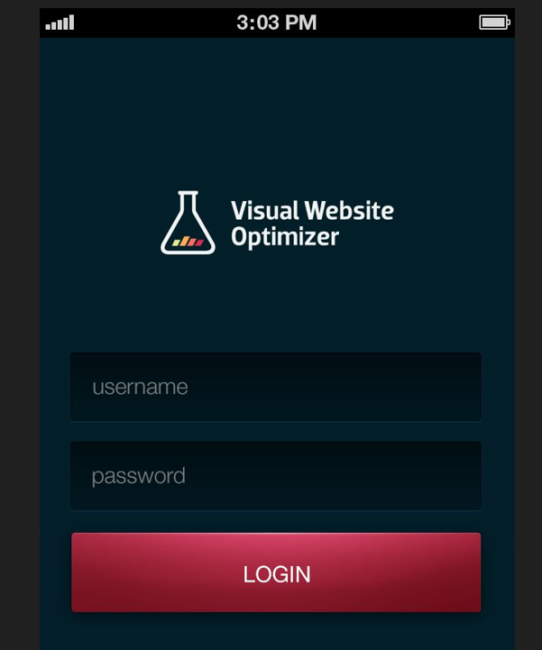

**Design one:**

